**Heading**

The Addictive Design of Mobile Games

Commerce / Behavioral Design / January 8th

Shreya Thothathri

40448 Winter 2023

**Introduction**

With hundreds of millions of people playing mobile games like candy crush, it’s hard not to wonder what makes them so addicting. Developers often use information gathered on consumer behavior through data aggregation to help make their games more popular amongst their audience, often with unintentional, dangerous consequences on their audience. These consequences not only effect the time and money users spend on their game without the user’s awareness of the strategies being used on them but also put users at a greater likelihood of addiction later down the line. This case study will describe the behavior design decisions rooted in psychology by exploring the design of popular types of mobile games.

**Case** and/or Examples

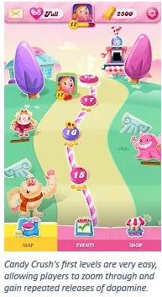This case study will describe the behavior design decisions behind popular mobile games and illustrate how users become addicted to these mobile games by exploring the design of some popular types of mobile games. First, a Google form focus activity based on the DSM-5 Internet Gaming Disorder entry was used on the audience in order to illustrate how subjective the boundary can be for when video game use goes too far and to show a distribution of how much time members of the audience play videogames in relation. It then explored examples of popular types of mobile games (puzzle games and idle clickers) and their strategies to keep players hooked before moving on to the discussion questions.

First, let’s analyze puzzle games like Candy Crush Saga and Tetris, based around solving puzzles to progress through levels. They usually begin with hooks to lure players in by using images that evoke positive feelings (ex. candy in Candy Crush Saga) and by making the beginning levels easy. Allowing users to speed through the first few levels not only allows for repeated releases of dopamine (a neurotransmitter that causes feelings of satisfaction and motivation) as players get satisfaction from beating each level but also helps reinforce the behavior of playing the game as dopamine plays a part in learning and addiction.

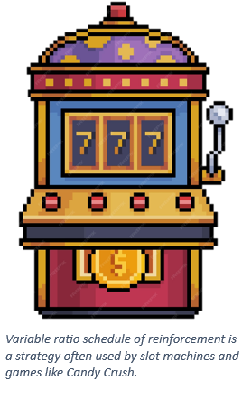As the game progresses, puzzle games often get more luck based. When they do and wins become unpredictable to the player, the strategy used to keep players hooked is known as variable ratio schedule of reinforcement which means that as the game becomes more luck based and wins become more unpredictable, users win just enough to keep coming back, a technique also used by slot machines.

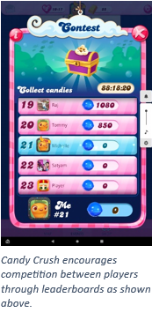Lastly, these puzzle games often utilize a social aspect of some kind to help motivate players. They encourage players to share their scores on social media or implement leaderboards that not only encourage players to interact but also to compete with friends, likely motivating them to play for longer than they would otherwise. By making the game a commonality between players and friends, they can keep players attached for longer as they compete.

The culmination of these factors creates very addictive games, with more than 9 million people spending at least 3 hours on Candy Crush every single day. When the developers of Candy Crush were asked if they believed that there was a problem with people getting addicted to Candy Crush, they not only refuted the claims but stated that in the 270 million people they have playing the game, only a few are concerning and when contacted, those few “say they are happy with what they are doing.” Originally, the maker of Candy Crush felt the need to intervene when players behaved concerningly and would send out emails to players that spent $250 in a week but found that those players found that practice intrusive, so he stopped.

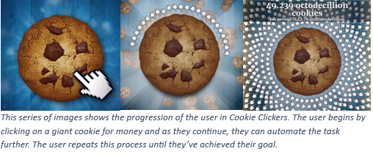Another popular type of mobile game is idle clickers. These games (also known as incremental or clicker games) usually start with the player clicking some type of object for an in-game currency or resource. As they progress, they buy items or hire workers to perform the task for them while they are offline and gain new tasks to complete, allowing players to repeat this cycle of getting new tasks and automating them as they continue.

These games often engage players using strategies like recurring gratification, a reward every time they return, interpassivity, and social interaction. Idle clickers utilize recurring gratification by bombarding players with notifications, visual and audio, every time a task is completed and by making early levels easy to complete. With players receiving so much positive input and satisfaction from completing required tasks quickly, they are again allowing for repeated releases of dopamine and are reinforcing the behavior of playing the game. Additionally, every time players leave and come back, they are rewarded on return and are given a screen summarizing how much they’ve made while away. This feature would cause satisfaction in the player and release dopamine to help reinforce the behavior of opening the app frequently. Idle clickers also engage in interpassivity by allowing their players to feel productive in the game despite their passivity due to the automation of their tasks. By making it easy for them to see everything that is being done and how much closer they are getting to a given goal, players feel as though they are participating even when they are not. Finally, these idle games often use features like friending people players know or implementing leaderboards to help players feel a sense of competition and give them motivation to play longer.

An example of an idle clicker that employs many of these strategies is Neku Atsume, a cat collecting game. When a 2019 study from the International Journal for Human Computer Studies was conducted on players of the game, it was found that two-thirds of players check the game more than twice a day, showing the value of a reward every return system, although many of these players checked briefly every time, suggesting that something else may be required to get them to stay. It was also found that almost 9 in 10 players discussed playing the game with other people showing the value of the social aspect of mobile games.

Through exploring these two types of games, it is clear that mobile games use recurring gratification, social aspects, and encouragement of players to check in often on the game to keep players addicted. When it comes to mobile games with wide audiences that include adults and children, developers should rethink the addictive features they add in when it exposes their users to the same tactics used on gamblers, especially so since gambling is illegal and harmful for children. On the other hand, some of these techniques allow developers to compete in a competitive environment where they need to increase engagement in order to make a profit and their competitors are using any tactics they can.

**Discussion**

The first question asked to the audience of this case study was where the boundary was between engaging users and addicting them to games. In this discussion, it was found that when a game begins to influence users to prioritize the game over their other life activities, it crosses the line. Deceptive marketing was found to cross the line when gambling methods were used on unwitting players. Much of the audience believes they have more control over the game and that it is more based on skill than luck than they do in some puzzle-based games and giving audience the knowledge crosses the line back from deceptive design to persuasive design. This question also had a second part meant to lead into the next case study on legislation of loot boxes. It asked how developers can protect their audience against getting too addicted to their games. As CS students are the future of game development and UI/UX design, it is their responsibility to learn about the consequences to their actions when creating addictive mobile games, especially when some features are rooted in gambling, so they can do so responsibly. It may also help them as, when used in moderation, using certain addictive features of these games could help them design games that are more likely to succeed or be enjoyed by their audience.

The second question asked was how these strategies can be used to increase player engagement for good. It wasn’t largely discussed by the audience but with research it was found that idle games are already used to make educational apps or informative apps more popular. A good example is Robinhood’s Forest, a persuasive idle game that works on improving investing behavior in stocks by teaching users about portfolio diversification and better trading habits.

This study most closely relates to the case study directly following this one on regulations on loot boxes. It introduced much of the content covered by the legislation presented. This case study also relates to the other case studies and discussions that attempt to balance the user’s interest (ex. privacy, health) with the developer’s interest. This could include the amazon and google listening in case study and the Googlenomics case study as well as others. It most closely relates to the social media data mining case as that case study explored how information about users could allow developers to make their platform addictive, often at the cost of their user’s.

References

Chaudhry, S. & Kulkarni, C. (2022, March 1). *Robinhood’s forest: A persuasive idle game to improve investing behavior*. ACM Digital Library. https://dl.acm.org/doi/10.1145/3490099.3511114

Cutting, J. (2018, September 8). *Busy doing nothing? what do players do in Idle Games?*. ScienceDirect. <https://www.sciencedirect.com/science/article/abs/pii/S1071581918305251>

Fizek, S. (2018, June). *Interpassivity and the Joy of Delegated Play in Idle Games*. ResearchGate. <https://www.researchgate.net/profile/Sonia-Fizek/publication/325826399_Interpassivity_and_the_Joy_of_Delegated_Play_in_Idle_Games/links/5b2a6c3d4585150c63413952/Interpassivity-and-the-Joy-of-Delegated-Play-in-Idle-Games.pdf>

*Internet Gaming*. American Psychiatry Association . (2023, January). <https://www.psychiatry.org/patients-families/internet-gaming>

Rabbani, H. R. (2023, March 24). *Exploring the psychology of Block Puzzle Gaming: What makes it so addictive?*. Medium. https://medium.com/@harisriazrabbani/exploring-the-psychology-of-block-puzzle-gaming-what-makes-it-so-addictive-57ff27d87a8e

Nheu, C. (2016, July 8). *What makes PokémonGo so addictive?*. Medium. https://medium.com/startup-grind/what-makes-pok%C3%A9mongo-so-addictive-a6a841bb5286

Smith, D. (2014, April 1). *This is what Candy Crush Saga does to your brain*. The Guardian. https://www.theguardian.com/science/blog/2014/apr/01/candy-crush-saga-app-brain

Sweney, M. (2018, June 26). *More than 9m play Candy Crush for three hours or more a day*. The Guardian. <https://amp.theguardian.com/games/2019/jun/26/more-than-9m-play-candy-crush-for-three-hours-or-more-a-day-addiction>

*The science behind addictive mobile games.* Medium. (2017, April 15). https://blog.prototypr.io/the-science-behind-addictive-mobile-games-825739790f3b